ED 3221- ELEMENTARY MATH METHODS
3 semester credits
Fall 2012

Instructor: Dr. Glen Richgels
Office: HS 360
Telephone: W: 755-2824 H: 444-5334
E-mail: grichgels@bemidjistate.edu
Office hours and advising: http://faculty.bemidjistate.edu/grichgels/Advising.html

Prerequisites: MATH 1011 (Early Childhood and Elementary Education majors) & 1013 (Elementary Education majors only.)

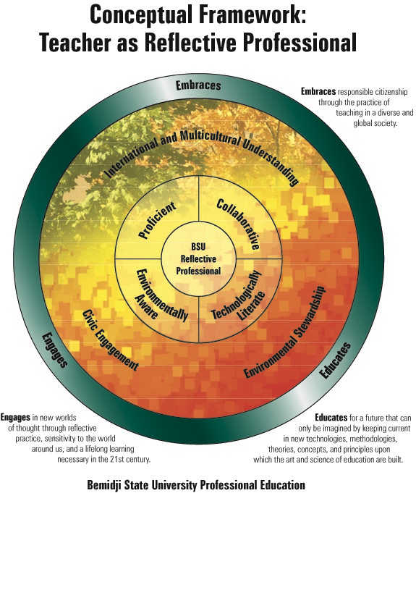
MISSION STATEMENT
BEMIDJI STATE UNIVERSITY TEACHER EDUCATION PROGRAM

Bemidji State University prepares teachers through inquisitive, involved, reflective practice. The framework outlining our program sets a standard that is rigorous, exemplary, and innovative. The curricular structure is research based and organized around the Standards of Effective Practice. Graduates are proficient, collaborative, technologically literate and environmentally aware teachers, who work effectively in various settings with diverse learners.

ED 3221 addresses the mission statement and conceptual framework by addressing the fundamental concepts of mathematics and the connection between these concepts. Students work with a problem-based approach to learning mathematics and become involved through planning, teaching, and peer-reviewing lessons and activities.

COURSE DESCRIPTION:
In this course, attention will focus on the art and science of teaching and learning mathematics; teaching with emphasis on planning effective instruction, management, and assessment; learning from constructivist views focusing on how student learning is influenced by cognitive development, teaching approaches, motivation, and other factors.
This is a methods course in which concepts are applied. Students are expected to address the course objectives at the application level.

Technology Requirements and Expectations
Students will use internet browsers to access information and answer questions posed in class. Students may use calculators, spreadsheets, and data programs such as Excel, Tinkerplots, Fathom 2, or Minitab to answer problems. Written assignments for class will be composed using a word processor such as Microsoft Word.

Teaching Methodology
Polya’s problem solving steps
  - Understand the problem
  - Devise a plan
  - Carry out the plan
  - Reflect

Lesson Sequencing
Intuitions ⇒ Concrete ⇔ Semi-Concrete ⇔ Abstract

Dr. Glen Richgels’ Teaching/Learning Principles
- Teach the way students learn
- Use group work, heterogeneous, 3-4, change monthly
- Communication student ⇔ student
- Communication student ⇔ teacher
- Multiple solution paths
- Use contextual settings / problem solving
- Assessment
  - Grading
  - To inform instruction

Instructional practices modeled after principles from Principles and Standards for School Mathematics and the Cognitively Guided Instruction research project from the University of Wisconsin-Madison (WCER).

University Policies and Procedures
http://www.bemidjistate.edu/students/handbook/policies/

Academic Integrity
BSU students are expected to practice the highest standards of ethics, honesty and integrity in all of their academic work. Any form of academic dishonesty (e.g., plagiarism, cheating and misrepresentation) may result in disciplinary action. Possible disciplinary actions may include failure for part of all of a course as well as suspension from the University.

Student Rights and Responsibilities
Student Code of Ethics
http://www.bemidjistate.edu/academics/catalog/10catalog/GradCatalog/Frontpages/sectionIV/rights.html
Student Academic Rights and Responsibilities
http://www.bemidjistate.edu/students/handbook/policies/academic_integrity/rights_responsibilities.cfm

Instructor Rights and Responsibilities
- I work with all students and expect success from all students. It is my expectation for those students who attend class regularly and complete assignments that they will earn an A or B.
- I am available for help whenever I am in my office. I encourage students to do homework at a table outside of my office so that I can help them whenever they have difficulties. Help is also available through email and at my home, if prior arrangements have been made.
- I will try to give grade status reports at least every three weeks.

Course Grades
A: 100 – 90% B: 89 – 80% C: 79 – 70% D: 69 – 60%
Course Policies
Attendance: Daily attendance is expected
Participation: Class participation and group work is expected

Commonly used Instructional Strategies facilitated by instructor of course:
- Constructivist (hands-on) Approach-Instructor takes a predominately constructivist approach to teaching the course
- Cooperative Groups-Small group discussions and activities
- Socratic Discussion-Large group discussions
- Collaborative Groups-Small group projects, peer review
- Lecture/presentation-Instructor presents key points from text reading or articles
- Exemplars-Instructor presents examples of assignments, lessons, or projects
- Modeling-Instructor models a variety of instructional strategies
- Demonstrations-Instructor shows examples of activities and assignments
- Discovery Learning-Instructor uses inquiry approach through in-class assignments and small and large group problem solving. Students design and complete inquiry-based lessons.

TEACHING AND ASSESSMENT METHODOLOGY:
The methodology used in teaching this course is built on “the learner-centered approach, which has been endorsed, by prominent leaders and theorists in higher education since the mid-1980s” (Huba and Freed, 2000, p.3).
- Students construct knowledge through gathering and synthesizing information and integrating it with general knowledge skills of inquiry, communication, critical thinking, and problem solving.
- Students are actively involved.
- Emphasis is on using and communicating knowledge effectively to address enduring and emerging issues and problems in real-life contexts.
- Professor’s role is to coach and facilitate.
- Teaching and assessing are intertwined.
- Assessment is used to promote and diagnose learning.
- Emphasis is on generating better questions and learning from errors.
- Desired learning is assessed directly through papers, projects, portfolios, and the like.
- Approach is compatible with interdisciplinary investigation.
- Culture is cooperative, collaborative, and supportive.
- Professor and students learn together.

RESOURCE TEXT:
Van de Walle, J. (2007) Elementary and middle school mathematics: Teaching developmentally. Boston: Allyn and Bacon.

SPECIAL ACCOMMODATIONS:
As required by Section 504 of the Rehabilitation Act, appropriate accommodations will be made for all students with documented disabilities. If you have a disability requiring accommodation in this class, please notify the instructor as soon as possible. This information will be kept confidential. Upon request this document can be made available in alternate formats. Please contact the instructor, Kathleen Sonsteng, at 755-4613 or Kathi Hagen in the Disabilities Services Office at 755-3883. Please contact the Disability Services Office ONLY if you have a need for accommodations for a documented disability in this class. All other contact should be with instructor only.

University Policies and Procedures including Student Rights and Responsibilities can be found at http://www.bemidjistate.edu/students

Minnesota Math Teaching Competencies

Subpart 3, Section H
A teacher of children in kindergarten through grade 6 must demonstrate knowledge of fundamental concepts of mathematics and the connection between them. The teacher must know and apply:

STANDARDS/INDICATORS | ASSIGNMENTS/ASSESSMENT
H (1) concepts of mathematical patterns, relations, and functions, including the importance of number and geometric patterns in mathematics and the importance of the educational link between primary school activities with patterns and the later conceptual development of important ideas related to functions and be able to:  - identify and justify observed patterns; (K)  - generate patterns to demonstrate a variety of relationships; (K) | Textbook chapters  Small and large group discussions  Math games  Lesson plans  Presentations  Practicum  Reflections
H (2) concepts and techniques of discrete mathematics and how to use them to solve problems from areas including graph theory, combinatorics, and recursion and know how to:  - help students investigate situations that involve counting finite sets, calculating probabilities, tracing paths in network graphs, (K) and analyzing iterative procedures; | Textbook chapters  Small and large group discussions  Math games  Lesson plans  Presentations  Practicum  Reflections
H (3) concepts of numerical literacy:  - possess number sense and be able to use numbers to quantify concepts in the students’ world; (K)  - understand a variety of computational procedures and how to use them in examining the reasonableness of the students’ answers; (K)  - understand the concepts of number theory including divisibility, factors, multiples, and prime numbers, and know how to provide a basis for exploring number relationships; (K) | Textbook chapters  Small and large group discussions  Math games  Lesson plans  Presentations  Practicum  Reflections
H (4) concepts of space and shape:  - understand the properties and relationships of geometric figures; (K)  - understand geometry and measurement from both abstract and concrete perspectives and identify real world applications; (K) and  - know how to use geometric learning tools such as geoboards, compass and straight edge, ruler and protractor, patty paper, reflection tools, spheres, and platonic solids; (K) | Textbook chapters  Small and large group discussions  Math games  Lesson plans  Presentations  Practicum  Reflections
H (5) data investigations:  - use a variety of conceptual and procedural tools for collecting, organizing, and reasoning about data; (K)  - apply numerical and graphical techniques for representing and summarizing data; (K)  - interpret and draw inferences from data and make decisions in a wide range of applied problem situations; (K) and  - help students understand quantitative and qualitative approaches to answering questions and develop students’ abilities to communicate mathematically; (K) | Textbook chapters  Small and large group discussions  Math games  Lesson plans  Presentations  Practicum  Reflections
H (6) concepts of randomness and uncertainty:  - probability as a way of describing chance in simple and compound events; (K) and  - the role of randomness and sampling in experimental studies; (K) | Textbook chapters  Small and large group discussions  Math games  Lesson plans  Presentations  Practicum  Reflections
H (7) mathematical processes:  - know how to reason mathematically, solve problems, and communicate mathematics effectively at different levels of formality; (K)  - understand the connections among mathematical concepts and procedures, as well as their application to the real world; (K)  - understand the relationship between mathematics and other fields; (K) and  - understand and apply problem solving, reasoning, communication, and connections; (K) and | Textbook chapters  Small and large group discussions  Math games  Lesson plans  Presentations  Practicum  Reflections
H (8) mathematical perspectives:  - know how to integrate technological and nontechnological tools with mathematics. (K) | Textbook chapters  Small and large group discussions  Math games  Lesson plans  Presentations  Practicum  Reflections

8710.3200 Teachers of Elementary Education
Subp. 3. Subject Matter Standards, elementary education.
- A teacher of children in kindergarten through grade 6 and either preprimary children age three and above, young adolescents in grades 5 through 8, or a world language and culture in kindergarten through grade 8 must:

Standards/Indicators | Assignments | Assessment
(1) understand and apply the research base for and best practice of kindergarten, elementary, and preprimary or middle level education; | Math games  Lesson plans  Practicum | Rubric score on math game  Lesson plan scores  Practicum self-reflection/cooperating teacher checklist and critique  *Assessed by narrative summaries scored with rubric
(2) understand and apply educational principles relevant to physical, social, emotional, moral, and cognitive development of young children through young adolescents; | Practicum  Classroom discussion  Practicum journal | Practicum self-reflection/cooperating teacher checklist and critique  *Assessed by narrative summaries scored with rubric
(6) apply the standards of effective practice in teaching students in kindergarten through grade 6 and either preprimary or middle level through a variety of early and ongoing clinical experiences with kindergarten or primary and intermediate students and either preprimary or middle level students within a range of educational programming models. (A) | Practicum | Successful completion of practicum (self reflection/cooperating teacher checklist and critique)  *Assessed by narrative summaries scored with rubric

Successful completion of the above standards further connects to the mission and conceptual framework by enabling candidates to work with a diverse population of students during their practicum placements, to collaborate with their cooperating teacher, and to encourage reflective thought and discussion surrounding the practicum experience.

GRADING FOR COURSE:
Grading will be done on a total point system.
A 100-95% B 94-85% C 84-75% D 74-60% F <60%

Rubric for Standards Narratives:

1- Unsatisfactory | 2-Basic | 3-Competent | 4-Proficient (e.g. Exemplary)
Artifact and reflection fail to meet minimum attainment of indicators within standard. | Artifact and reflection demonstrate minimal attainment of indicators within the standard. | Artifact and reflection demonstrate satisfactory attainment of indicators within the standard. | Artifact and reflection demonstrate excellence across indicators within the standard.

Lesson Format
Lesson plan format models can be found at this www site:
http://faculty.bemidjistate.edu/grichgels/

Tentative CLASS CALENDAR AND ASSIGNMENTS

Class Meeting Day
1 | Orientation; Math Ed Assign Notebook of Artifacts; History of Mathematics Achievement and International Studies
2 | NCTM documents from Agenda for Action to present; NSF Texts; NAEP Achievement 1978-2003  4th 2.5+ grade levels  8th 2 grade levels  12th flat line
3 | TIMSS video US; Patterns, Rabbits Rules  - month 1, 1 pair of newborn rabbits  - following month newborn rabbits mature  - every month afterwards mature rabbits give birth to a newborn pair  , Fibonacci, Nature and Fractals; Handshake / Hugs problem, sum of consecutive integers.
4 | TIMSS Japan; Principles
5 | Miss Tolliver; Content Standards
6 | Process Standards
7 | Lesson plan format LESA;  Geometry problem tennis ball can problems: circumference vs height, percent of can that is air
8 | Practicum
9 | Practicum
10 | Number sense activity – envelopes, place value, relationships, clues; Prepare Numerical literacy presentation; NCTM Curriculum Focal Points
11 | Prepare pattern presentation
12 | Prepare discrete presentation
13 | Numerical literacy presentation
14 | Pattern presentation
15 | Discrete presentation
16 | Fraction presentation RNP
17 | Geometry presentation
18 | Data presentation
19 | Probability presentation
20 | Fraction presentation RNP

